Birla Institute of Technology,Mesra,

Patna Campus



**SE-Assignment**

Name-Shubham Sourabh

Roll-Btech/15044/18

Sec-CSE 6th

#Assignment-2

1.Draw use case diagram for library managementsystem .

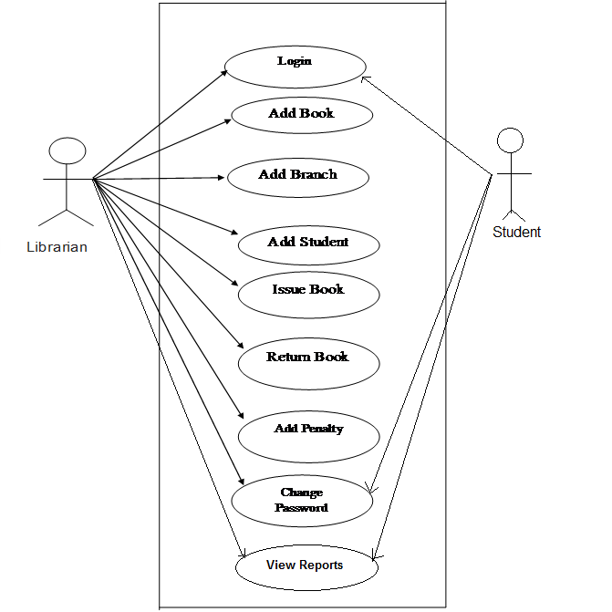

2. Draw use case diagram for online shopping.

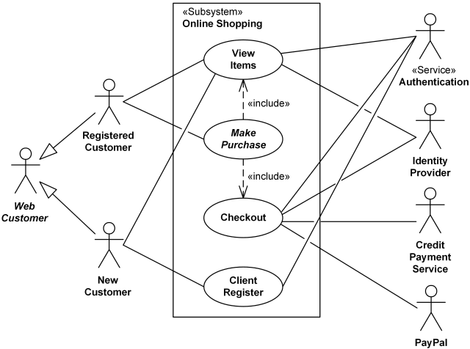

3. Draw class diagram for supermarket.

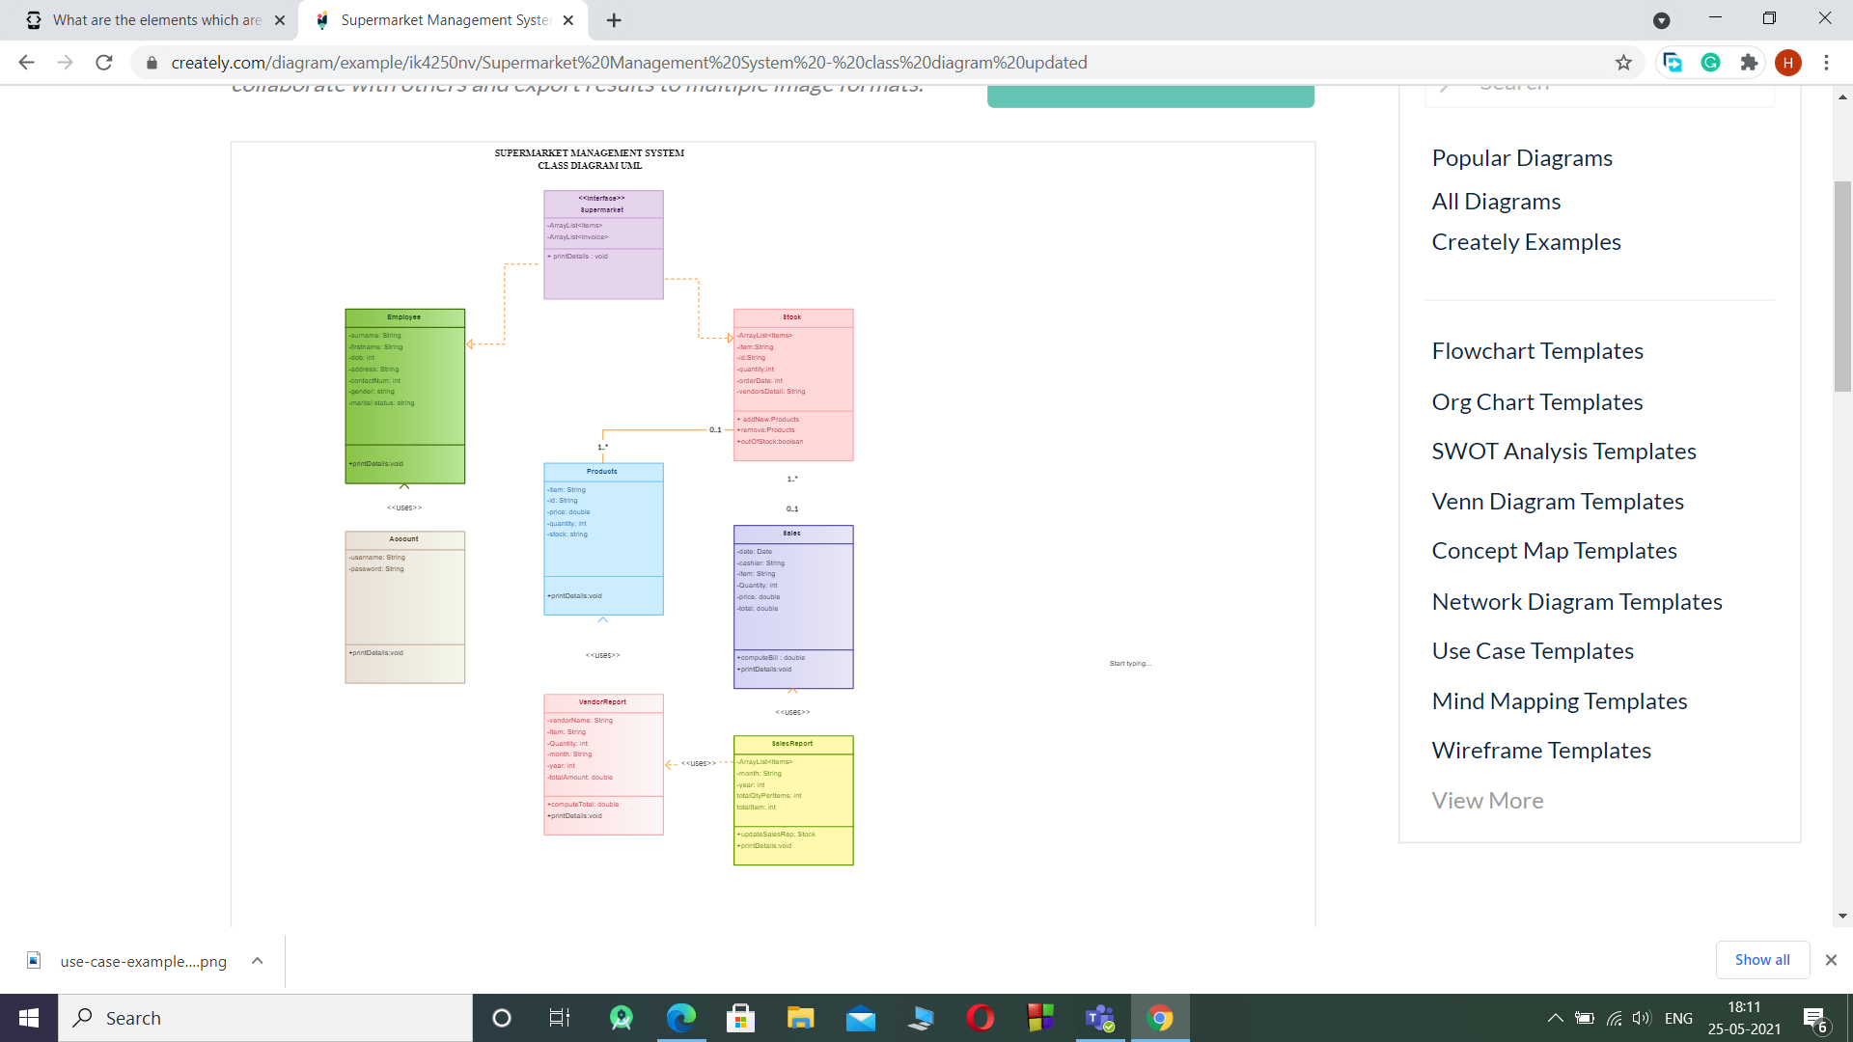

4. Draw class diagram for ATM system.

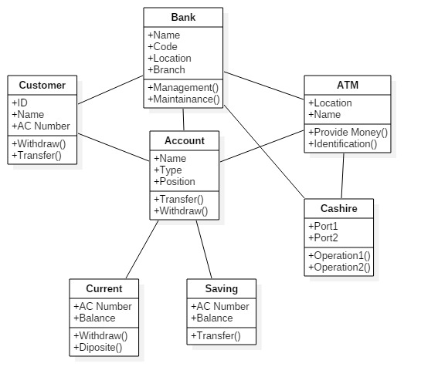

5. Draw activity diagramfor hospital management.

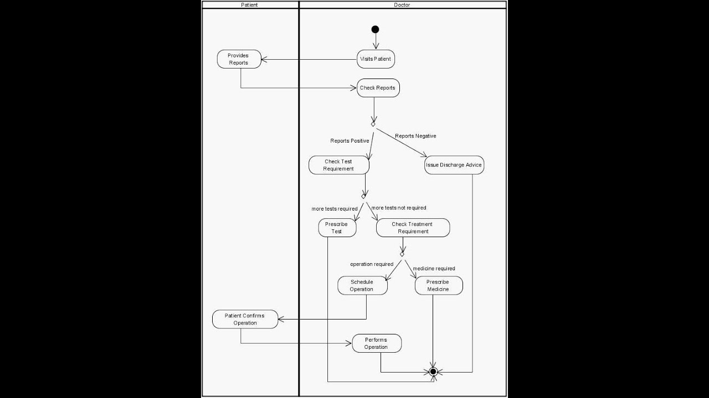

6. Draw sequence diagram for banking system.

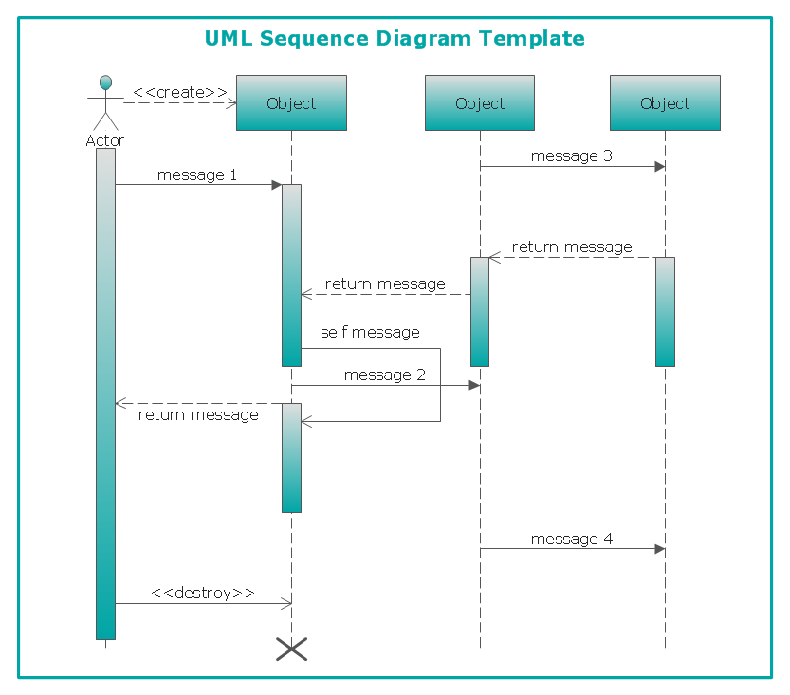

7. Draw collaboration diagram for online food ordering system.

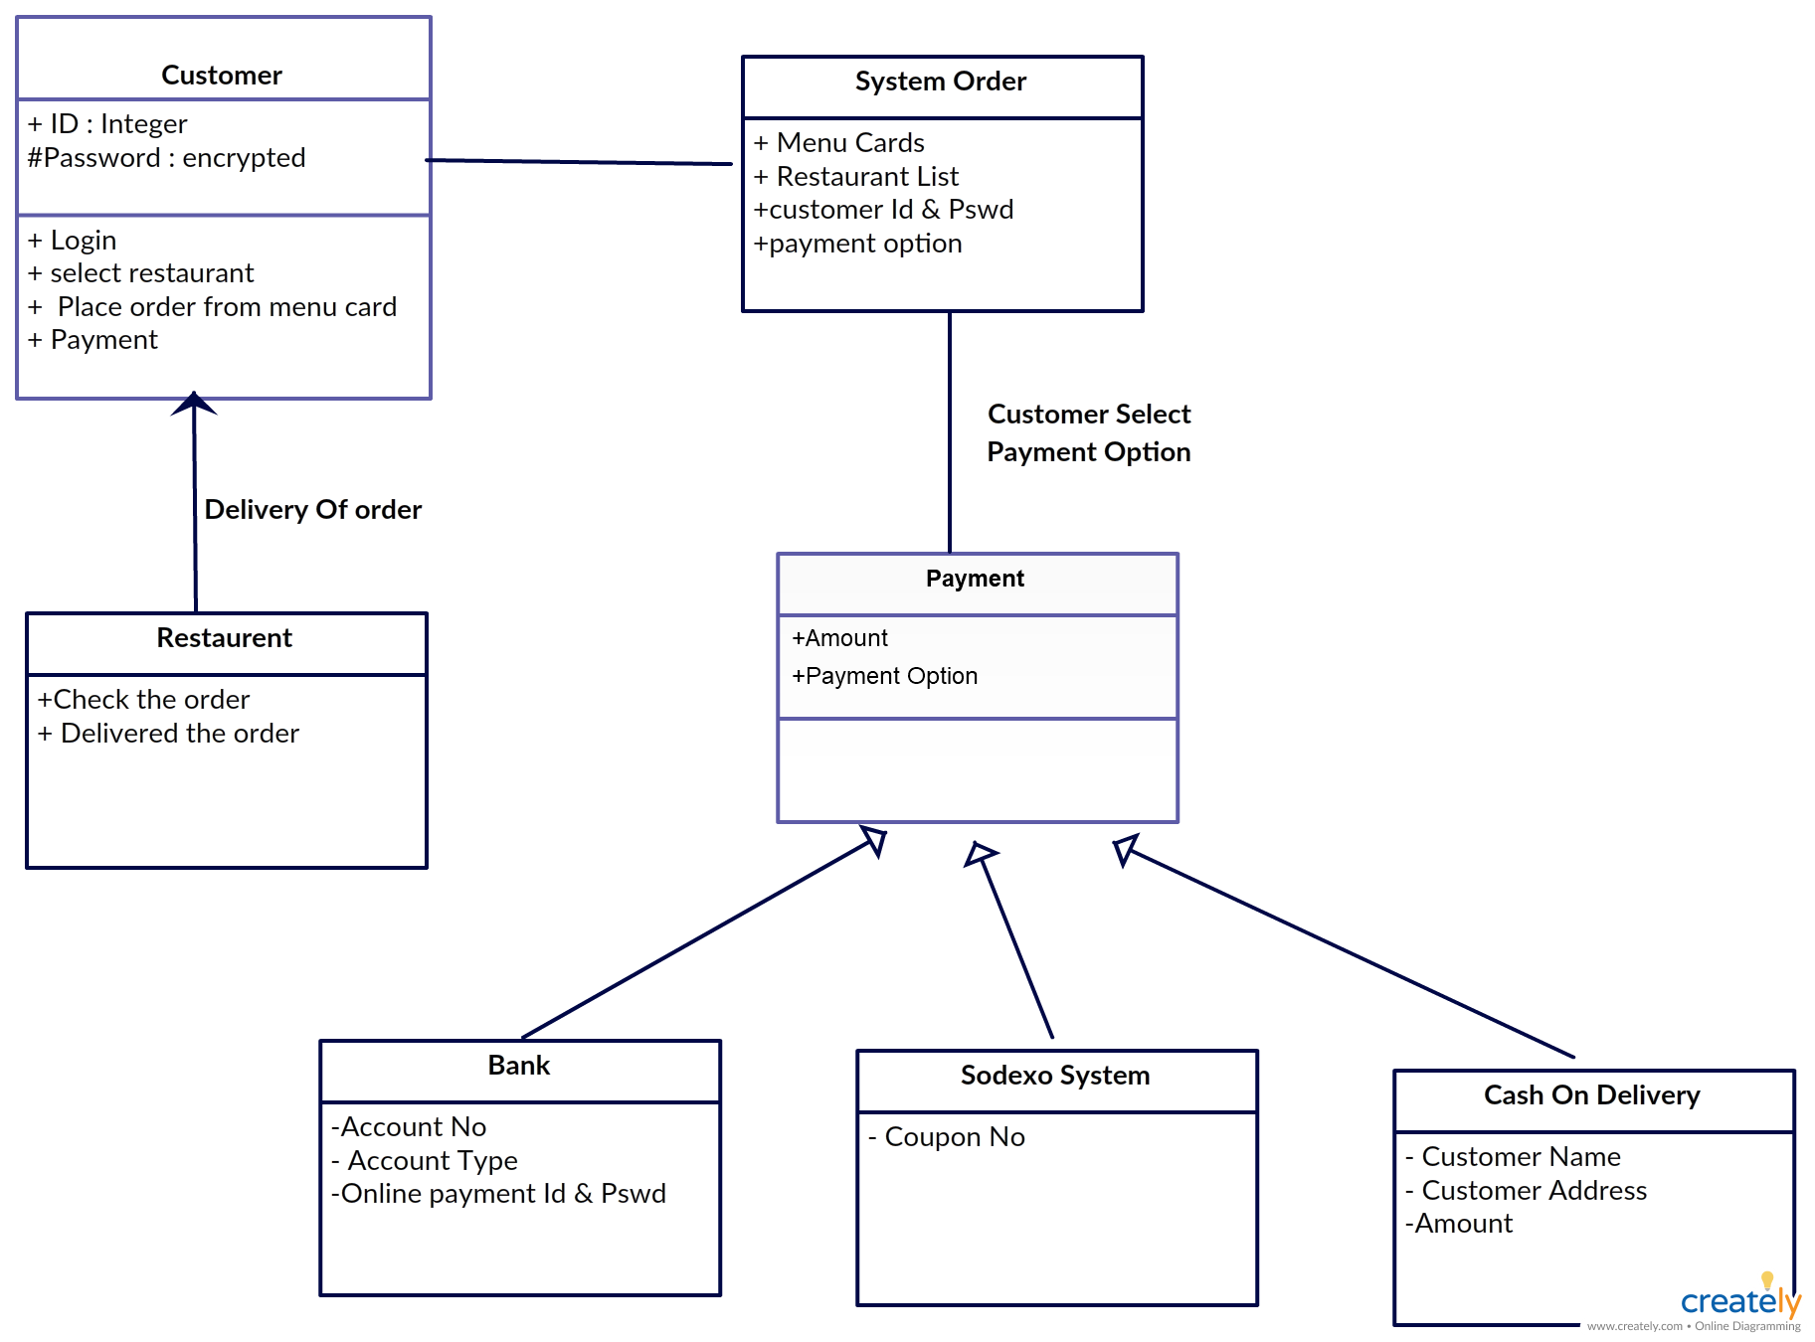

8. Draw state chart diagram for hotel management.

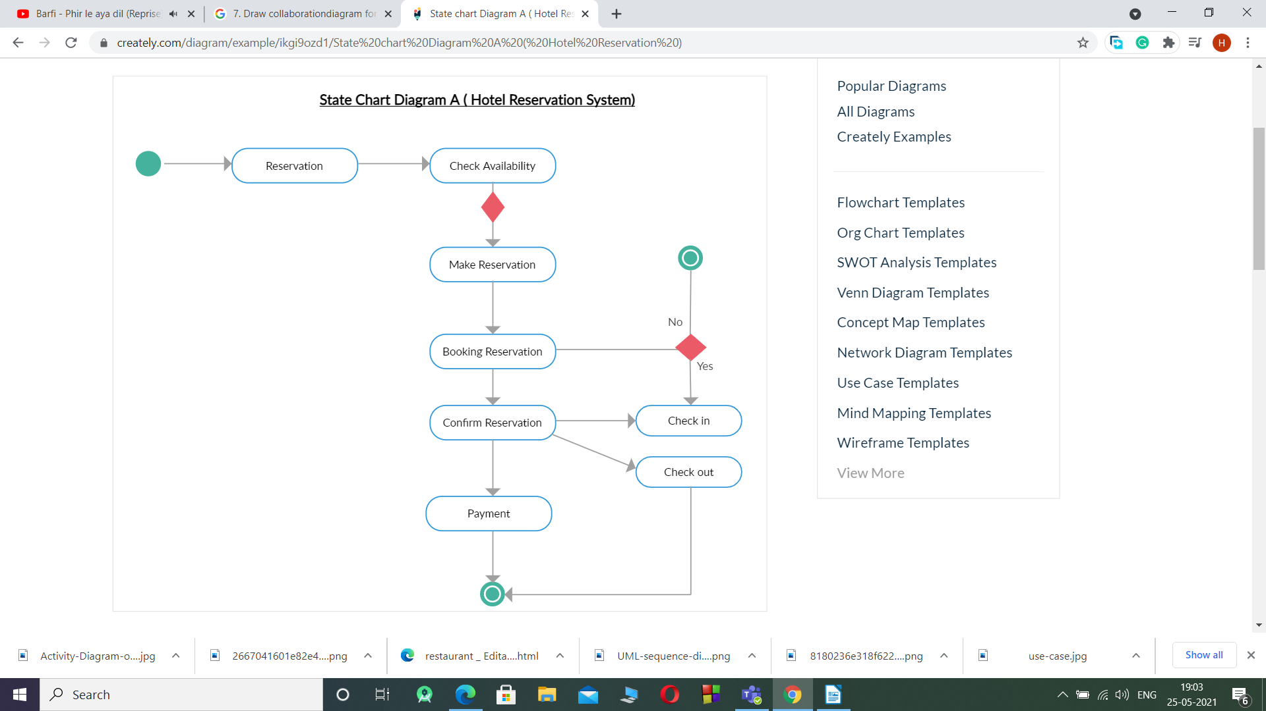

9. Draw context level diagram for airline reservation system.

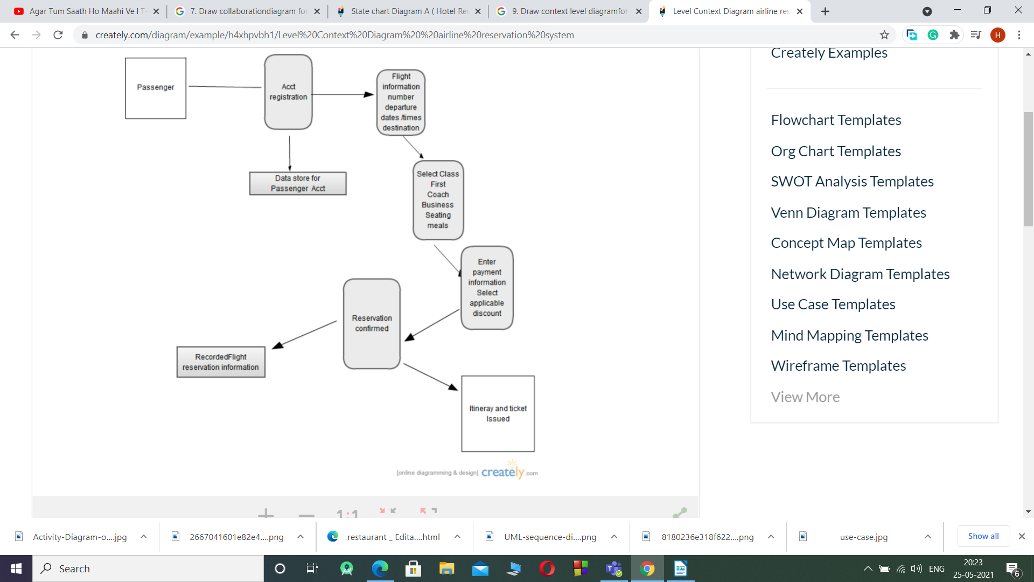

10. Draw component diagram for college management system.

